SPRINT-3

|  |  |
| --- | --- |
| TEAM ID | PNT2022TMID24757 |
| Project Name | IoT Based smart crop Protection system for agriculture |
| Maximum mark | 20 marks |

STEP1: Simulated program to get the random values.

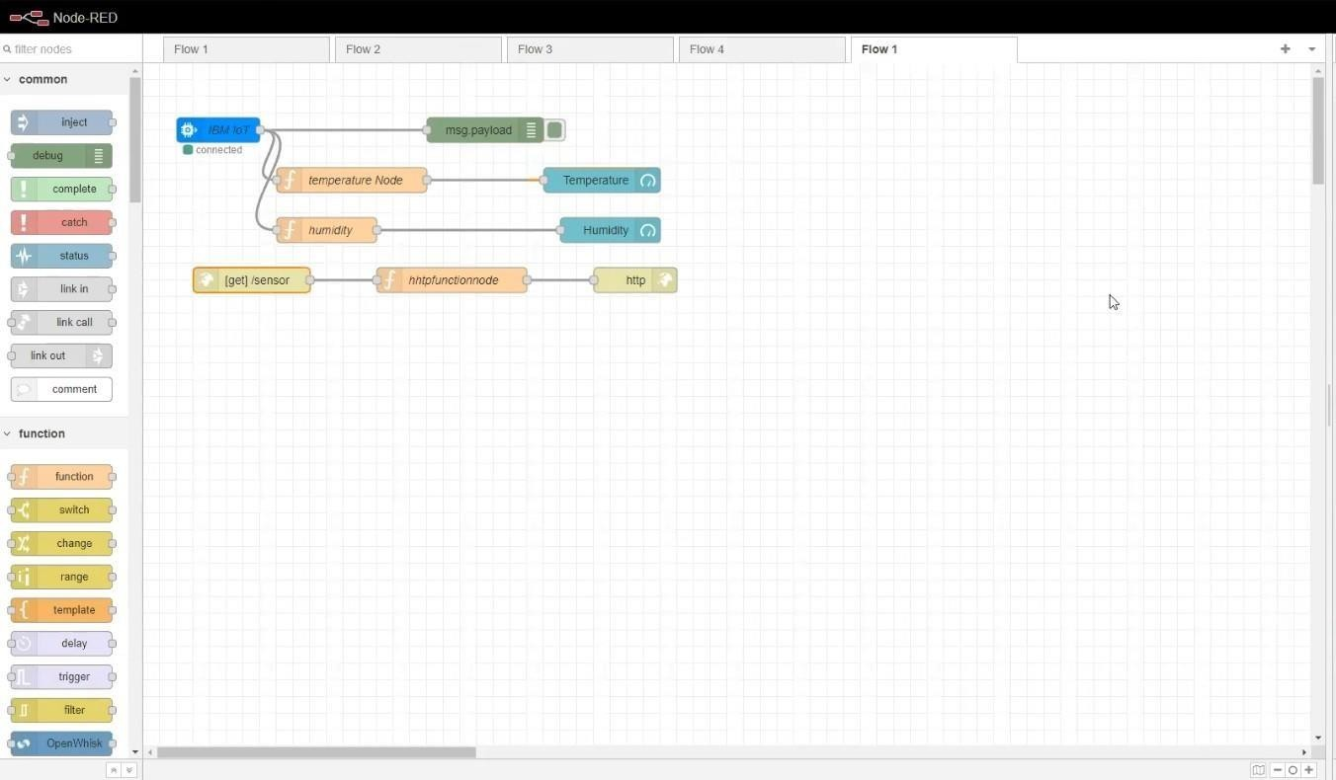

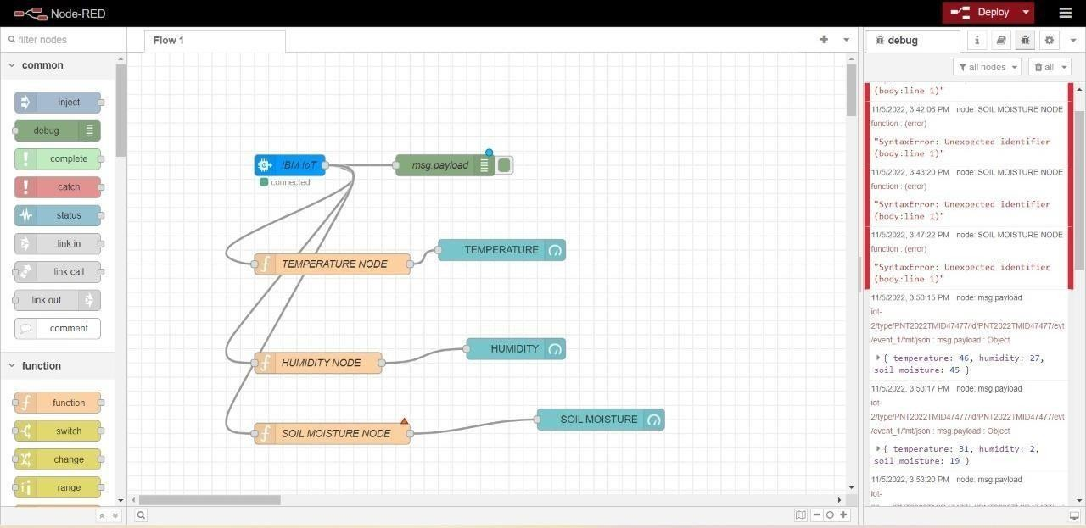

STEP2: Generate debug message from IBM Watson IoT Platform and connect the nodes. STEP3: Generate the some output from recent events.

